**Assignment -3**

Cloud object storage and Watson assistant

|  |  |
| --- | --- |
| Student Name | DHINAKARAN R |
| Team id | PNT2022TMID04575  **Explore AS, differentiate** |
| Project Name | PERSONAL EXPENSE TRACKER |

**Question-1:**

Create a Bucket in IBM object storage

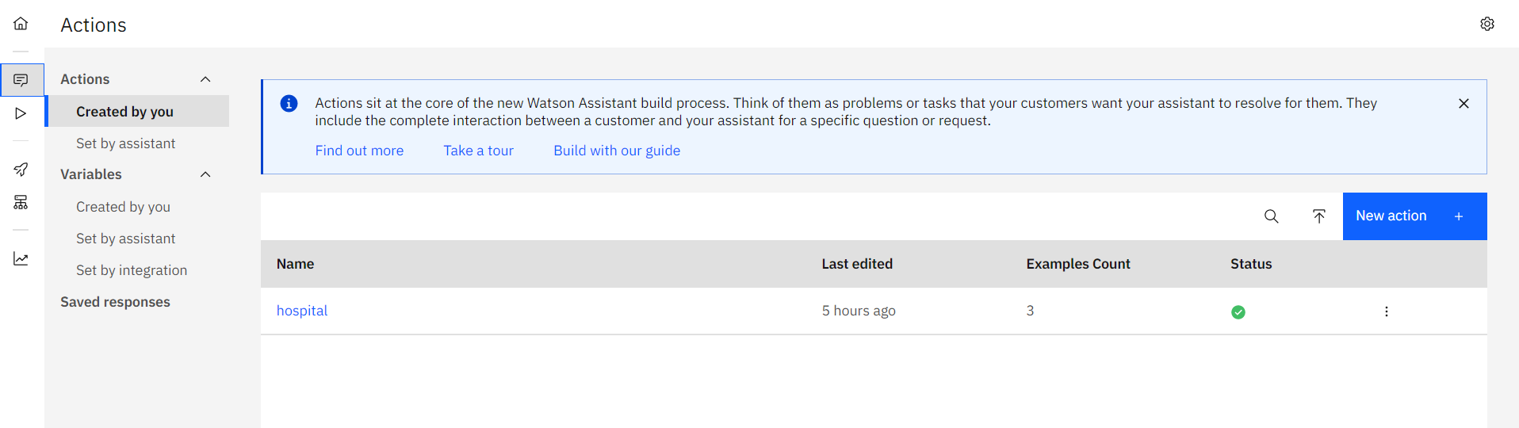

**Question-2:**

Upload an 5 images to ibm object storage and make it public. Write html code to displaying all the 5 images.

**HTML CODE**

<!DOCTYPE html>

<html lang="en">

<head>

    <meta charset="UTF-8">

    <meta http-equiv="X-UA-Compatible" content="IE=edge">

    <meta name="viewport" content="width=device-width, initial-scale=1.0">

    <title>Assignment 3</title>

    <link rel="stylesheet" href="assignment3.css"></link>

</head>

<h1> Images with css file</h1>

<body>

    <script>

        window.watsonAssistantChatOptions = {

          integrationID: "d8c5c59c-3e1f-4cfd-84dd-3d04dd0853cd", // The ID of this integration.

          region: "us-south", // The region your integration is hosted in.

          serviceInstanceID: "5ed71154-8ec7-49c1-8357-771d3f911d3b", // The ID of your service instance.

          onLoad: function(instance) { instance.render(); }

        };

        setTimeout(function(){

          const t=document.createElement('script');

          t.src="https://web-chat.global.assistant.watson.appdomain.cloud/versions/" + (window.watsonAssistantChatOptions.clientVersion || 'latest') + "/WatsonAssistantChatEntry.js";

          document.head.appendChild(t);

        });

      </script>

    <div class="container">

    <div class="gallery">

        <div class="gallery-item">

            <img class="gallery-image" src="https://s3.jp-tok.cloud-object-storage.appdomain.cloud/team344252/bike1.jpeg">

        </div>

        <div class="gallery-item">

            <img class="gallery-image" src="https://s3.jp-tok.cloud-object-storage.appdomain.cloud/team344252/bike2.jpeg">

        </div>

        <div class="gallery-item">

            <img class="gallery-image" src="https://s3.jp-tok.cloud-object-storage.appdomain.cloud/team344252/bike3.jpeg">

        </div>

        <div class="gallery-item">

            <img class="gallery-image" src="https://s3.jp-tok.cloud-object-storage.appdomain.cloud/team344252/bike4.jpeg">

        </div>

        <div class="gallery-item">

            <img class="gallery-image" src="https://s3.jp-tok.cloud-object-storage.appdomain.cloud/team344252/bike5.jpeg">

        </div>

    </div>

</div>

</body>

</html>

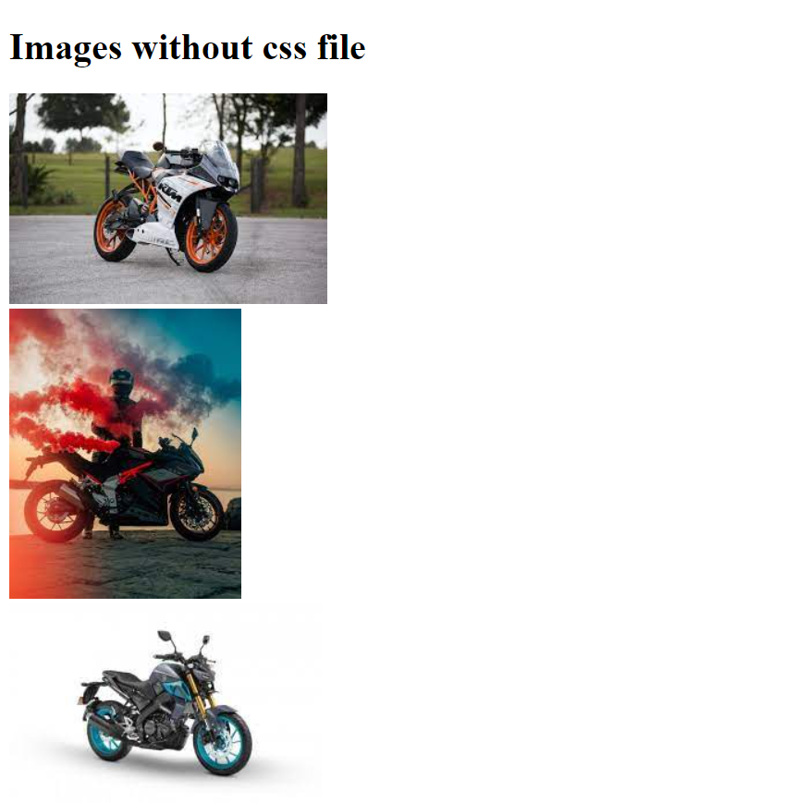



**Question-3:**

Upload a css page to the object storage and use the same page in your html code.

**INCLUDING CSS FILE IN HTML**

<link rel="stylesheet" href="assignment3.css"></link>

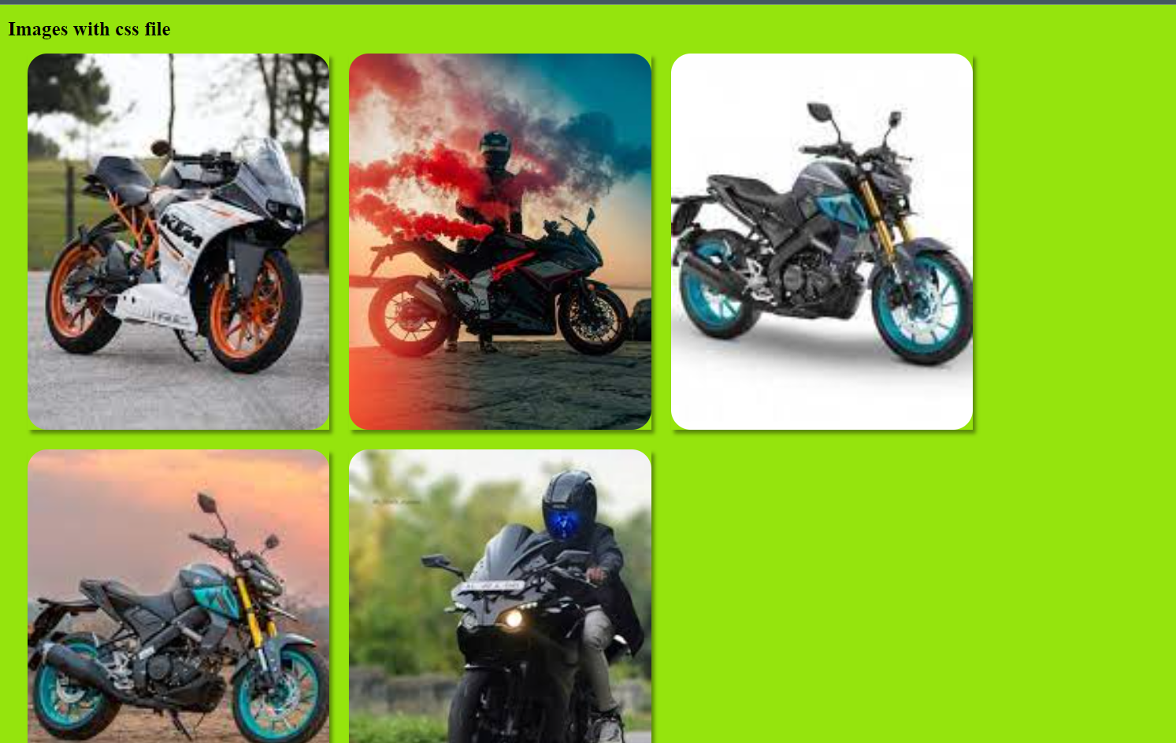

**Question-4:**

Design a Chabot using IBM Watson assistant for hospital. Ex: User come the query to know the braches for that hospital in your city.

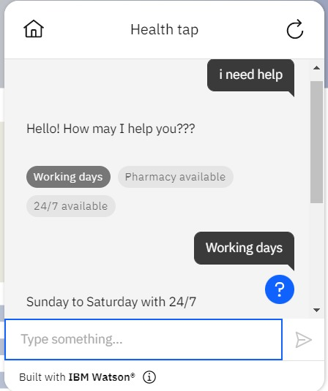

**Question-5:**

Create Watson assistant service with 10 steps and use 3 conditions in it. Load that script in html page.

**INCLUDING CHATBOT USING THIS SCRIPT IN HTML**

<script>

window.watsonAssistantChatOptions = {

integrationID: "d8c5c59c-3e1f-4cfd-84dd-3d04dd0853cd", // The ID of this integration.

region: "us-south", // The region your integration is hosted in.

serviceInstanceID: "5ed71154-8ec7-49c1-8357-771d3f911d3b", // The ID of your service instance.

onLoad: function(instance) { instance.render(); }

};

setTimeout(function(){

const t=document.createElement('script');

t.src="https://web-chat.global.assistant.watson.appdomain.cloud/versions/" + (window.watsonAssistantChatOptions.clientVersion || 'latest') + "/WatsonAssistantChatEntry.js";

document.head.appendChild(t);

});

</script>

